**`**

**Explorer robot**

**Components**

**Chapter 3**

**Hardware component**

**3.1 Introduction**

Hardware component of explorer robot are divided in three units each units contains one or more component are explain below.

**3.2 Input Unit**

An input unit peripheral e.g. sensor ,power supply these sensor used to sense data signal from surround area and pass than to processing unit . I can see area detection by use of smart phone as ip camera to run the consolations use the shield.

**3.2.1 Ultrasonic Sensor**

An Ultrasonic sensor is a device that can measure the distance to an object by using sound waves.

It measures distance by sending out a sound wave at a specific frequency and listening for that sound wave to bounce back. By recording the elapsed time between the sound wave bein generated and the sound wave bouncing back, it is possible to calculate the distance between

the sonar sensor and the object.

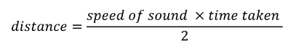

Since it is known that sound travels through air at about 344 m/s

(1129 ft/s), you can take the time for the sound wave to return and

multiply it by 344 meters (or 1129 feet) to find the total round-trip

distance of the sound wave. Round-trip means that the sound wave

traveled 2 times the distance to the object before it was detected by

the sensor it includes the 'trip' from the sonar sensor to the object

and the 'trip' from the object to the Ultrasonic sensor (after the sound

wave bounced off the object). To find the distance to the object, simply

divide the round-trip distance in half.

It is important to understand that some objects might not be detected

by ultrasonic sensors. This is because some objects are shaped or

positioned in such a way that the sound wave bounces off the object,

but are deflected away from the Ultrasonic sensor. It is also possible

for the object to be too small to reflect enough of the sound wave back

to the sensor to be detected. Other objects can absorb the sound wave

all together (cloth, carpeting, etc), which means that there is no way

for the sensor to detect them accurately. These are important factors

to consider when designing and programming a robot using an ultrasonic sensor.

**3.2.2 Accelerometer**

An accelerometer is a device that measures proper acceleration. Proper acceleration, being the acceleration (or rate of change of velocity) of a body in its own instantaneous rest frame, is not the same coordinate acceleration, being the acceleration in a fixed coordinate system.

For example, an accelerometer at rest on the surface of the Earth will measure an acceleration due to Earth's gravity, straight upwards (by definition) of g ≈ 9.81 m/s2. By contrast, accelerometers in free fall will measure zero.

Accelerometers have multiple applications in industry and science . Highly sensitive accelerometers are components of inertial navigation systems for aircraft and missiles. Accelerometers are used to detect and monitor vibration in rotating machinery. Accelerometers are used in tablet computers and digital cameras so that images on screens are always displayed upright. Accelerometers are used in drones for flight stabilization.

Modern accelerometers are often small micro electro-mechanical systems (MEMS), and are indeed the simplest MEMS devices possible, consisting of little more than a cantilever beam with a proof mass (also known as seismic mass). Damping results from the residual gas sealed in the device. As long as the Q-factor is not too low, damping does not result in a lower sensitivity.

**3.2.3 Shield**

The Dual DC Motor Shield is a shield that has been projected to enable an ARDUINO board to drive two brushed DC motors or one wire two-phase stepper motor, controlling the speed and direction of each one independently. Some applications may need to control the motor speed or a servo angular position by a potentiometer; for these reasons in this shield two digital I/O ports and two analog input ports have been added.

Analog input ports can be used to read potentiometers or any other analog sensor, while digital I/O ports can be used to drive servos or interface other digital devices. This shield is based on the L298, a high voltage , high current dual full-bridge driver . To prevent board damages, all drive r lines are diode protected from back EMF. The maximum supply voltage supported by this board is 46. The logic of the Dual DC Motor Shield is powered directly from the Arduino board, whereas motor outputs can be powered both from Arduino Vin pin or from external power source, even if it is strongly encouraged to use external power supply.

**3.2.4 ip camera**

An Internet protocol camera, or IP camera, is a type of digital video camera commonly employed for surveillance, and which, unlike analog closed circuit television (CCTV) cameras, can send and receive data via a computer network and the Internet. Although most cameras that do this are webcams , the term "IP camera" or "NETCAM" is usually applied only to those used for surveillance.

**3.3 The processing unit**

The processing unit is an important element in the system because it is heart of system means it is analysis and processes the event the come from the input devices and control the output devices this unit can be microprocessor or atmega16 ARDUINO.

**3.3.1 Microcontroller**

A microcontroller (or MCU for microcontroller unit) is a small computer on a single integrated circuit. In modern terminology, it is a system on a chip or SOC. A microcontroller contains one or more CPUs (processor cores) along with memory and programmable input/output peripherals. Program memory in the form of Ferroelectric RAM, NOR flash or OTP ROM is also often included on chip, as well as a small amount of RAM. Microcontrollers are designed for embedded applications, in contrast to the microprocessors used in personal computers or other general purpose applications consisting of various discrete chips.

Microcontrollers are used in automatically controlled products and devices, such as automobile engine control systems, implantable medical devices, remote controls, office machines, appliances, power tools, toys and other embedded systems. By reducing the size and cost compared to a design that uses a separate microprocessor, memory, and input/output devices, microcontrollers make it economical to digitally control even more devices and processes. Mixed signal microcontrollers are common, integrating analog components needed to control non-digital electronic systems. Some microcontrollers may use four-bit words and operate at frequencies as low as 4 kHz, for low power consumption (single-digit mw or microwatts). They will generally have the ability to retain functionality while waiting for an event such as a button press or other interrupt; power consumption while sleeping (CPU clock and most peripherals off) may be just nw, making many of them well suited for long lasting battery applications. Other microcontrollers may serve performance-critical roles, where they may need to act more like a digital signal processor (DSP), with higher clock speeds and power consumption.

**3.3.2 ATmega 16**

At mega 16 is an 8bit high performance microcontroller of Atmel's mega AVR family with low power consumption. Atmega16 is based on enhanced RISK (Reduced Instruction Set Computing, know more about RISK and CISC Architecture) architecture with 131 powerful instruction. Most of the instruction execute in one machine cycle. Atmega16 can work on a maximum frequency of 16MHz.

ATmega16 has 16 KB programmable flash memory, static RAM of 1 KB and EEPROM of 512 Bytes.

ATmega16 is a 40 pin microcontroller. There are 32 I\O(input, output) lines which are divided into four 8-bit ports designated as PORTA, PORTB, PORTC and PORTD.

**3.3.3 ARDUINO**

Board based on the at mega 328 (datasheet) .it has 14 digital input output pins (of which 6 can be used as PWM outputs) 6 analog inputs ,a 16 MHz ceramic resonator a USB connection a power jack an ICSP header and a reset button it contains everything needed to support the microcontroller simply connect it to a computer with a USB cable or it with a ac to dc adapter or battery to get started .

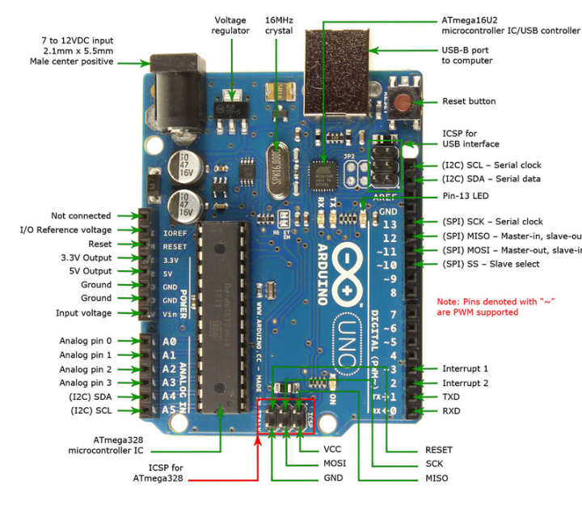

The Adriano show as figure (3.4) Uno is microcontroller

**3.4 Output unit:**

**3.4.1 Servo Motor**

A servo motor is an electrical device which can push or rotate an

object with great precision. If you want to rotate and object at some

specific angles or distance, then you use servo motor . It is just

made up of simple motor which run through servo mechanism . If

motor is used is DC powered then it is called DC servo motor, and if

it is AC powered motor then it is called AC servo motor. We can get

a very high torque servo motor in a small and light weight packages.

Doe to these features they are being used in many applications like

toy car, RC helicopters and planes, Robotics, Machine etc.

**3.4.2 Dc Motor**

A dc motor is any of a class of electrical machines the converts direct current electrical power into mechanical power the most common types on the forces production by magnetic field nearly all types of dc motors have some internal machine either electromechanical or electronic to periodically change the direction of current flow in part of the motor most types production rotary motion a linear motor directly produces force and motion in a straight line.

Dc motor were the first type widely used since they could be powered from existing direct current lighting power distribution power system a dc motors speed can be controlled over a wide range using either a variable supply voltage on by changing the strength of current in its field windings small dc motor are used in tools toys and application the universal motor can operate on direct current but is a lightweight motor used for portable power tools and application large dc motor are used in propulsion of electric vehicles elevator and hoists or in drives for steel rolling mills the advent of power electronics has made replacement of dc motor with ac motor possible in many application ,

A coil of wire with a current running through it generator an electromagnetic field aligned with the center of the coil the direction and magnitude of the magnetic field production by the coil can be changed with the direction and magnitude of the current flowing through it.

A simple dc motor has a stationary set of magnets in the stator and an armature with one or more windings of insulated wire wrapped around a soft iron core that concentrates the magnetic field the windings usually have multiple turns around the core and in large motors there can be several current paths the ends . The ends of the wire winding re connected to a commentator. The commentator allows each armature coil to be energized in turn and connects the rotation coils with the external power supply through brushes.

The sequence of turning a particular coil on or off dictates what direction the effective electromagnetic field are pointed by turning on and off coils in sequence a rotating magnetic field can be created these rotating magnetic field interact with the magnetic field of the magnets (permanents or electromagnets)in the stationary part of the motor (stator) to create a force on armature which cases it to rotate in some dc motor designs the stator field use electromagnets to create their magnets field which allow greater control over the motor at high power levels , dc motor are almost always cooled using forced air.

Different number of stator and armature field as well as how they are connected provide different inherent speed/torque regulation Characteristics the speed of dc motor can be controlled by changing the voltage applied to the armature the introduction of variable resistance in the armature circuit or field circuit allowed speed control modern dc motor are often controlled by power electronics system which adjust the voltage by "chopping" the dc current into and off cycles which have an effective lower voltage Since the series –wound dc motor develops its highest torque at low speed it is often used in traction application such as electric locomotives and trams the dc motor was the marnstay of electric traction driver on both electric and diesel –electric locomotives street car/trams and siesel electric drilling rigs for many years the introduction of dc motors and an electrical grid system to run machinery stating in the 1870 started anew second industrial revolution dc motor can operate directly from rechargeable batteries providing the motive power for the first electric vehicles and today's hybrid car and electric car well as driving a host of cordless tools today dc motors are still found in application as small as toys and disk driver or in large sizes to cooperate steel rolling mills and paper machine. large dc motor with separately excited field were generally used with winder drivers for mine hoists for high torque as well as smooth speed control using thyristor drives these are now replaced with large ac motors with variable frequency drives.

If external power is applied to a dc motor it acts as a dc generator a dynamo this feature is used to slow down and recharge batteries on hybrid car and electric cars or to return electricity back to the electric grid used on street car or electric powered train line when they slow down this process is called regenerative braking on hybrid and electric cars in diesel electric locomotives they also use their dc motors as generators to slow down but dissipate the energy in resistor stacks newer designs are adding large battery packs to recapture some of this energy.